**Junior High Supply List 2023-2024 (6/7/8th grade)**

* Pencils (#2)
* Pens (blue-black)
* Composition notebooks (4 to begin the year with/ 2 ELA/ 2 Math)
* One 3 inch 3 ring binder (for ELA/ found at Staples)
* Plastic Dividers/ taps/colored (found at Staples)

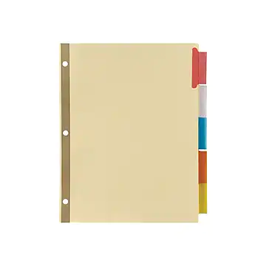

* Loose-Leaf paper (3 lined/ ELA)
* Graph paper packet (3/Math)
* Index cards (small - 3 packs for vocabulary)
* Sticky notes (light colors)
* Stapler and Staples
* Glue sticks
* Scissors
* Markers ( black and colored)
* Colored Pencils
* Highlighters (2 yellow, 2 green, 2 light blue, 2 pink, and 2 orange/ ELA)
* Math Tool Set (Compass, Protractor, Ruler, Calculator) found at Staples
* Calculator
* Water (3 Cartons for 6th/ 3 cartons for 7th/ 3 cartons for 8th)
* Religion Notebook (2 thin spiral/ 1 for Science and 1 for Religion)
* $28.00: cost of a new Bible (for incoming 6th grade only/price depending on the publisher this year)

The following items are classroom supplies that will be collected during the first week of school and used by the class as a whole over the school year:

* 4 large boxes of Kleenex tissues (4 boxes for 6th/ 4 boxes for 7th/ 4 boxes for 8th)
* 4 containers of Clorox Wipes (4 for 6 th/ 4 for 7th/ 4 for 8th)
* 3 large rolls of paper towels ( 3 for 6th/ 3 for 7th/ 3 for 8th)
* 3 reams of copy paper (3 for 6th/ 3 for 7th/ 3 for 8th)
* 2 packages of whiteboard markers